Kirissa Byington

CS340

2/25/24

Project Two: README

## **About the Project**

This project was created to allow a user, Grazioso Salvare, to access a functional and web-based dashboard containing animal information at the Austin Animal Shelter so they may search and filter as needed. The project was composed utilizing MongoDB for the data, Python for development of the program, and a visualization created through the use of Dash. The Python component contains a created class named CRUD that functions as the basis for the program to create, read, update, and delete data within the MongoDB, pymongo, driver. The CRUD class contains all constructors and methods for manipulating databases as well as the ability to instantiate the server connection.

## **Motivation**

This program was created and designed in this course to test and improve my skills relating to database environments and data manipulation. Utilizing Jupyter notebook, I was able to quickly and efficiently create Python code and compile it as needed in conjunction with MongoDB to serve the purposes of this course. Python was able to seamlessly work together with MongoDB to manipulate the data with my CRUD class and final dashboard project code.

## **Getting Started**

The necessary components to get started with this project include:  
1. Start with MongoDB and successfully upload the provided AAC csv into the database.

2. Then create an index that will be simple enough to navigate and manipulate the stored data.

3. Create an admin account and a personal “aacuser” account with a set password for connecting and accessing the database through MongoDB.

4. Install or utilize Python to run the program through Jupyter notebook.

5. Instantiate the username and password to access the database and dashboard.

6. Finally, create the CRUD.py file and subsequent Dashboard file to successfully create the dashboard.

## **Installation**

MongoDB - to access the database.

Required installations:

MongoDB- for accessing the database.

Python- current version to run the .py files

Jupyter Notebook- current version to run the .ipynb files

Access to import and connect to PyMongo, Dash, Pandas, and Leaflet- for creating the necessary functions for this project.

**Requirements**

- Logo for branding purposes

- Data Table with options to filter the animal information within the provided .csv file

-Filters should include Water Rescue, Mountain or Wilderness Rescue, Disaster Rescue or Individual Tracking, and Reset

-A pie chart or other visualization tool to show the breakdown or summary of available breeds

-A geolocation map to visualize the selected animals' location.

### **Code Example**

Unfortunately, due to a continuous time out error when running my code in Jupyter, I was unable to get my dashboards to populate to show examples and screenshots to show proof of my created code. Below I have included the screenshots showing the timeout error I received for further review.

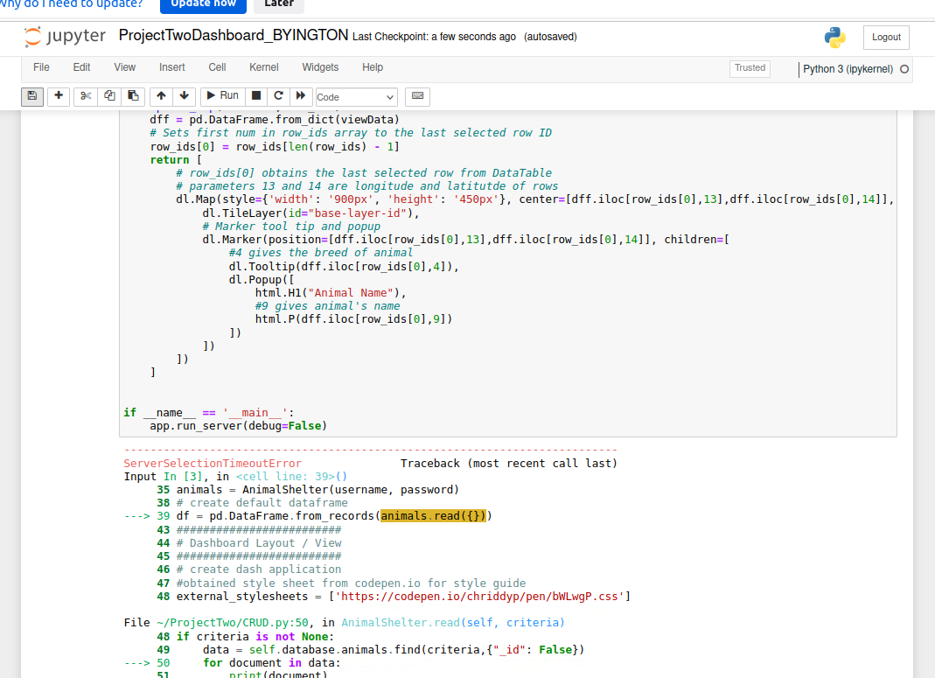

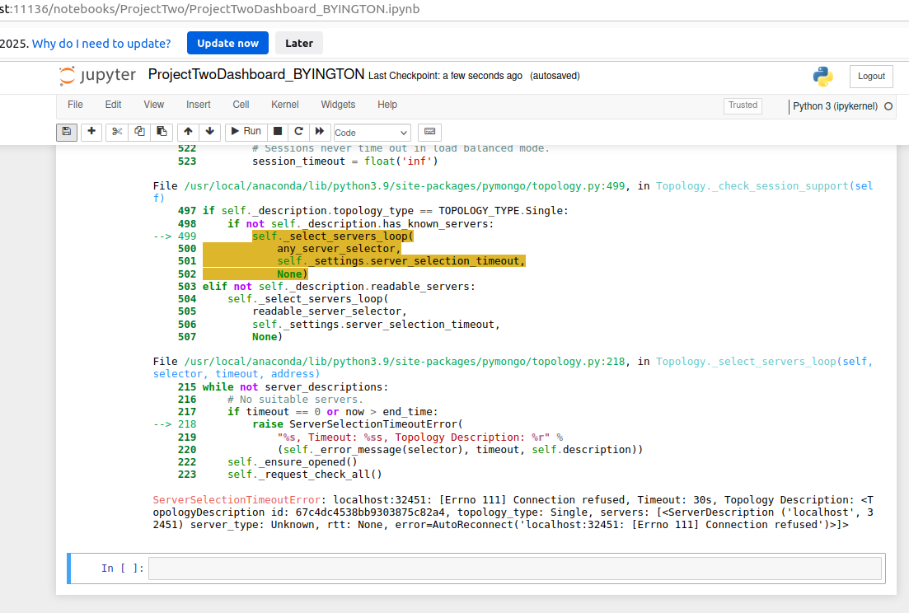

## **Errors**

As far as my actual coding goes the main issue, I was experiencing was the AnimalShelter class containing one argument, self, which would throw an error when running the code to utilize my username and password. To overcome this error, I went back into my original CRUD.py file and updated the code from:

def **init**(self):

To

def **init**(self, username, password):

Additionally, I ran into a reoccurring issue I have been having with Visual Studio I believe. I keep running into Server Timeout Exception due to the query taking too long to run. I have confirmed that my MongoDB information is instantiated correctly within my code with my host number but I'm still getting the timeout error. Due to this I am unable to review my final dashboards to provide examples.

## **Contact**

Your name: Kirissa Byington